# PRAIRIE LAKE IMPROVEMENT ASSOCIATION

[Type a quote from the document or the summary of an interesting point. You can position the text box anywhere in the document. Use the Drawing Tools tab to change the formatting of the pull quote text box.]

**May 2017**

Prairie Lake Improvement Association priorities support **responsible lake use, water quality and shore land management.**

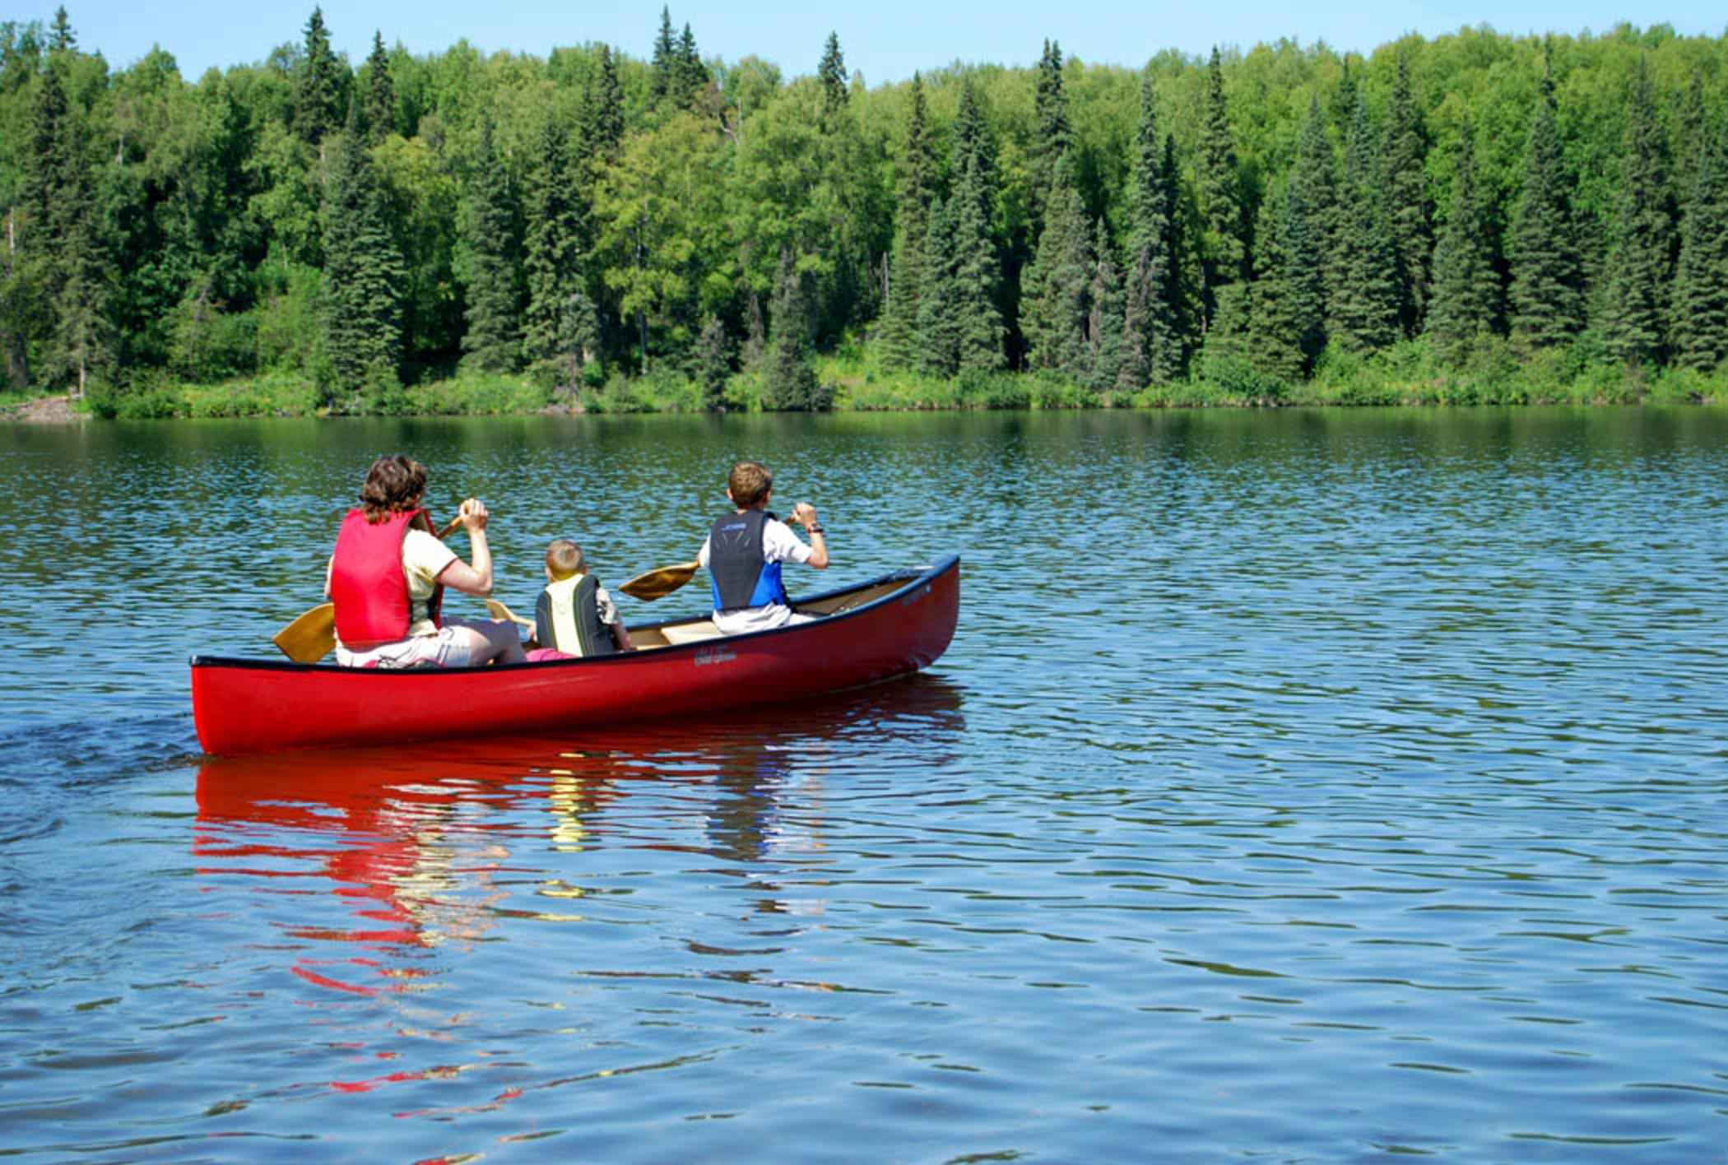

**Prairie Lake Improvement Association Meetings**

**Memorial Day Weekend**

**&**

**Labor Day Weekend**

**Sunday, 1:30 PM**

**Fine Lakes Town Hall**

**JOIN the Prairie Lake Improvement Association NOW!**

**Make $20 checks payable to Prairie Lake Improvement Association and send to:**

**…………………………………………………………………………………………………….**

**Sandy Fontaine, Treasurer**

**3372 Stark Junction Road**

**Duluth, MN 55810**

**Name\_\_\_\_\_\_\_\_\_\_\_\_\_\_\_\_\_\_\_\_\_\_\_\_\_\_\_\_\_\_\_\_\_\_\_\_\_\_\_\_\_\_\_\_\_\_\_\_\_\_\_\_\_\_\_\_\_\_\_\_\_\_\_\_\_\_\_\_\_\_\_**

**Home Phone\*\_\_\_\_\_\_\_\_\_\_\_\_\_\_\_\_\_\_\_\_\_\_\_\_\_Email\*\_\_\_\_\_\_\_\_\_\_\_\_\_\_\_\_\_\_\_\_\_\_\_\_\_\_\_\_\_\_\_\_\_**

**\*Please list if you want this information included in the Prairie Lake Directory.**

**JOIN and receive an updated directory of all cabin owner names, address, phone and their home address and phone.**

**THANKS to 91** out of **167** owners that joined in **2016**

**Prairie Lake Improvement Association Officers and Directors**

**President:** Merritt Linzie (2017)

**Vice-President:** Scott Moncur (2017),

**Treasurer:** Sandy Fontaine (2017)

**Secretary:** Bob Sanft (2017),

**Directors:** Richard Collman (2019), Bob Stemwedel (2017), Ken Hallberg (2018)

**Elections** are held at the Memorial Weekend meeting. Participation is encouraged.

**Many of the Officers and Directors have volunteered to serve the Prairie Lake Improvement Association for over 10 years.** Some are anxiously waiting for replacements to be elected. Listed below are some of the responsibilities of the positions:

Officers are elected to serve 1 year terms

**President**

* Preside over 2 meetings each year
* Participate in the Big Sandy Area Lakes Watershed Management Project
* Communicate with the membership and stakeholders.

**Vice-President**

* Act in absence of the President
* Support and assist the direction of the Lake Association

**Treasurer**

* Collect and deposit membership fees
* Verify and pay bills
* Report financial transactions and fiscal status

**Secretary**

* Record and report meeting activities

**Directors** are elected for 3 year terms

* Provide consultation, advice and support at and between meetings
* Participate in activities and decisions between meetings

All of the functions and duties are adaptable to your style, desires and skills.

**A DAMAGING THUNDERSTORM** pounded the region on **July 21, 2016**. Straight-line winds between 70 and 100 miles per hour, hail, torrential rain and continuous lightning produced hurricane like damage. The storm left 27,000 without Lake Country Power and personal property damage as well.

**Lake Country Power** plans power line clearing this year in the Prairie Lake area.

**ADOPT-A-HIGHWAY** segmen**t** onHighway 73 has been discontinued after 25 years by the Prairie Lake Improvement Association. **THANKS** to all those that helped in the past.

**CENTURY FARM** designation was given to the **Collman** family for 100 years of continuous ownership. Henry Collman purchased property in 1916 and was later assisted by his son Forest Collman in 1938 with his sons, Richard and Arnold and later Arnold’s son Eric. The century Farm program is sponsored by the Minnesota State Fair and Minnesota Farm Bureau. Since 1976, more than 10,000 farms have been recognized.

**ADOPT-A-BUOY** project now has 7 volunteers placing and removing 9 buoys. **THANKS** to **Mike Baden**, **Joe Beaupre**, **Kris Beck**, **Ed Felien**, **Gene Kelly** and **Tom Sheetz**.

General guidance for volunteers is to place the buoys in May, preferably before fishing season or Memorial weekend. Remove the buoys after Labor Day weekend and before early October. The buoys are stored outside at the volunteer’s cabin.

**THANKS** to **Scoot Moncur** (651-433-4516) for coordinating this activity. Scott has GPS coordinates for each buoy location and he also has 3 extra buoys.

**BEAVER** damage to shore land trees prompted the Prairie Lake Improvement Association to contract for beaver management. By the fall of 2016, nineteen beavers were captured at a costof $1040. Beaver population has increased on Prairie Lake due to very low market prices.

The association Officers and Directors would appreciate some feedback about this program,.

**WATER QUALITY** testing during the summer of 2016 produced the following results:

Average of tests Impairment level

Total Phosphorus 33.2 30

Chlorophyl-a 16.1 10

Clarity less than 4 ft.

Sulfate less than 3mg/liter

Calcium 11.7ppb

Water testing has indicated that nutrients of phosphorus and chlorophyll levels frequently exceed their water quality impairment standards. Continuous failure to meet standards would result in an extensive Total Maximum Daily Load study and plan to meet the lake’s recreational uses. This may likely suggest pollutant reductions from developed areas. Prairie Lake is not listed as impaired by nutrients in the MN Pollution Control Agency 2016 list of “impaired” waters.

Prairie Lake, and many others, is listed as “impaired” by mercury. This results in advisories to limit the eating of fish.

**THANKS** to **Ken Hallberg** for collecting water quality samples for several years.

Governor Dayton announced a water quality goal to improve Minnesota’s water quality 25% by 2025. Without additional action, the quality of Minnesota’s water is expected to improve only 6% to 8 % by 2034.

**FISHING –** Information from Dan Wilfond, DNR Fisheries Specialist, Duluth, MN

**Prairie Lake** fish surveys will move from a 5 year rotation to an 8 year rotation due to DNR budget limitations. The next survey will be in 2023. The Governor has proposed a modest increase in DNR license and other fees. However, if passed, it will only allow DNR to continue operations at the current level and not expand programs or increase monitoring.

**Northern Pike** special regulation continues on **Prairie Lake**. **The limit is one northern 30 inches or greater.** An early ice out trapping of Northern Pike in 2019 will be evaluated to see if changes to the special regulation are warranted.

**Northern Pike** limits for other lakes are undergoing rule changes that plan to be implemented for the **2018** season. Three different zones are proposed for MN each designed to encourage larger Northern Pike. Too many small pike, generally less than 22 inches, in a lake can reduce perch numbers, tip the balance toward smaller pan fish and reduce effectiveness of walleye stocking.

**Largemouth Bass** range expansion project is underway by DNR in 9 northeastern MN lakes including **Prairie Lake**. Vegetation survey data and water temperature monitoring will evaluate Prairie Lake’s suitability for supporting a natural growth of Largemouth Bass

**Walleye** stocking will continue every other year. The stocking rates will be reduced to rates normal for other lakes. Higher stocking rates over the past has not improved the Walleye fishery in Prairie Lake. An improvement may result from a normal stocking rate of 270,000 fry every other year.

**Lead Free** fishing tackle are strongly encouraged to avoid lead poisoning of loons, eagles and other wildlife.

The large **Chinese and banded MYSTERY SNAILS** are a **“regulated invasive species”** in Minnesota. They are legal to possess or transport, but not legal to introduce those species of mystery snails into a new lake or river. Other **“prohibited invasive species”,** like zebra mussels, are not legal to possess, transport or introduce into lakes or rivers

**MCAN00573_0000[1] *LOON*** monitoring is regularly supported through an annual contribution

to DNR non-game wildlife program.

**Please** don’t use your boat or jet ski to chase or bother Loons.

**Do not** go within 100 feet of nesting Loons.

**Minnesota** has a stable population **Loons,** the largest in the U.S., of about 12,000 breeding adults. Loons tend to stop reproducing on lakes where shore land development exceeds 40 buildings per mile.

**BIG SANDY AREA LAKES WATERSHED MANAGEMENT PROJECT** (BSALWMP)

BSALWMP’s main purpose is to reduce phosphorous and suspended solids in 49 lakes and 5 rivers in the 413 square mile watershed that drains to the Mississippi River. Programs include information, education, technical assistance, citizen water quality monitoring, shore land revegetation and protection, conservation easements and improved agricultural practices.

Best management practices are encouraged:

* Shore land revegetation
* Lakeshore protection – erosion & runoff control
* Rain Gardens and rain barrels
* Forest Stewardship Plans
* Conservation Easements

MCNA02446_0000[1]**Information and education** is also an important activity:

* Watershed wide newsletters
* Lakeshore Homeowners Guide
* Big Sandy Water Institute
* Lake association newsletters
* Participation in information fairs
* Small neighborhood meetings

**Compliance with state and local regulations** are reviewed:

* Special permits ▪ Comprehensive Plans

**Technical and Financial assistance is available for revegetation of shorelines with native trees, shrubs, and/or flowering plants. For more information or assistance, call Aitkin County SWCD at 218-927-6565.**

Watershed meetings are usually held the second Wednesday of the month. The location varies so call 218-927-6565 for times and place.

**LOOK for a newsletter mailing this spring from BSALWMP**

The **UPPER MISSISSIPPI RIVER** watershed (between Lake Itasca and Twin Cities) is in great shape until pollutants flow in from farmland and cities. By the time it reaches Minneapolis, it no longer meets water quality standards for river life and recreation. Results from a new study by the Minnesota Pollution Control Agency highlight the need to **protect** wetlands and forests in the river’s northern areas while **taking action** to curb pollution in its southern reaches.

**BIG SANDY LAKE DAM** was first built of wood in 1895 to improve navigation on the Mississippi River. The Corp of Engineers now manages the site for recreation with 60 camp sites, visitor center, boat launches, beaches and play grounds. The dam manages the Big Sandy

Lake water level at 1214.31 feet + or -0.25 feet with a winter drawdown of 2 feet October through February.

**MN Lakes & Rivers Advocates mission is to protect Minnesota’s lake and river heritage for current and future generations by forging powerful links among lakes, lake advocates, and policy makers.**

Current topics of state legislative interest are:

* Remove or reduce cabins from the State Business Property Tax
* Protect AIS funding.
* Promote “sustainable shore lands”

The Prairie Lake Improvement Association annually contributes to MN Lakes & Rivers Advocates. 180 lake associations out of about 500 have joined MN Lakes & Rivers.

A 2015 **LAKE MINNIWAWA** survey of shore owners indicated about 21% were permanent residents and 60% of all owners have been there for over 15 years. Favorite lake experiences are; fishing, boating, being there, wildlife and swimming in that order.



**People and Businesses** who install or remove water recreation equipment (boats, docks, boat lifts, etc.) must be trained, certified and permitted by the DNR.

Inspect your boat, trailer and equipment and remove plants, zebra mussels and mud before leaving water access.

* **Drain** water from bait buckets, live well, bilge, transom and motor before leaving
* **Dispose** of unwanted live bait and worms in the trash
* **Spray/wash** your boat, trailer and equipment with high pressure or hot water before going to other waters, or
* **Dry** everything for at least 5 days.
* **A decontamination station will be available at Willey’s, Highway 65 north of McGregor during the week. T**he decontamination station will be moved to various boat landings during weekends.

Six **PROPERTY OWNERSHIPS changed** this past year and home address changes of 5 other owners.

**VISIT** the **Prairie Lake** web site at[**http://www.prairielake.org**](http://www.prairielake.org)**. Corinne Moncur** is the siteeditor at [**moncur@frontier.net**](mailto:moncur@frontier.net)